Example 1:

Configuring a basic string application

package com.library.LibraryManagement;

import org.springframework.context.ApplicationContext;

import org.springframework.context.support.ClassPathXmlApplicationContext;

import com.library.repository.BookRepository;

import com.library.service.BookService;

/**

* Hello world!

*

*/

public class App

{

public static void main( String[] args )

{

System.out.println( "Hello World!" );

ApplicationContext context = new ClassPathXmlApplicationContext("applicationContext.xml");

BookService bs = (BookService) context.getBean("bookService");

bs.bookServiceShow();

BookRepository br = (BookRepository) context.getBean("bookRepository");

br.bookRepositoryShow();

}

}

Output:

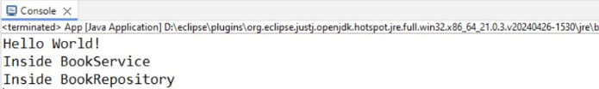

Example 2:

package com.library.LibraryManagement;

import org.springframework.context.ApplicationContext;

import org.springframework.context.support.ClassPathXmlApplicationContext;

import com.library.repository.BookRepository;

import com.library.service.BookService;

/**

* Hello world!

*

*/

public class App

{

public static void main( String[] args )

{

System.out.println( "Hello World!" );

ApplicationContext context = new ClassPathXmlApplicationContext("applicationContext.xml");

BookService bs = (BookService) context.getBean("bookService");

bs.bookServiceShow();

}

}

Output:

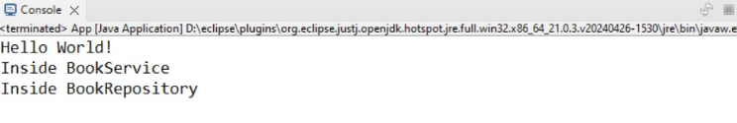

Example 4:

package com.spring_maven.LibraryManagement;

import junit.framework.Test;

import junit.framework.TestCase;

import junit.framework.TestSuite;

/**

* Unit test for simple App.

*/

public class AppTest

extends TestCase

{

/**

* Create the test case

*

* @param testName name of the test case

*/

public AppTest( String testName )

{

super( testName );

}

/**

* @return the suite of tests being tested

*/

public static Test suite()

{

return new TestSuite( AppTest.class );

}

/**

* Rigourous Test :-)

*/

public void testApp()

{

assertTrue( true );

}

}

Output:

